EXPERIMENT : 05

NAME: KRISHNAKUMAR.R ROLL NO:240701275

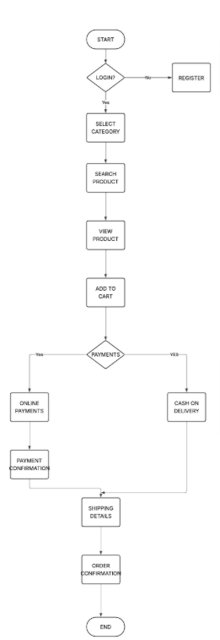

Experiment Title:
Flowchart for Online Shopping System
Aim:
To study and understand the working process of an Online Shopping System using a flowchart.
Objective:
To explain how a user purchases a product through an online shopping platform step by step.

Explanation / Procedure:
- Start:
The process begins when the user opens the online shopping application or website.
- Login:
The system checks whether the user already has an account.
  - If the user has an account, they log in using their credentials.
  - If the user does not have an account, they must register first.
- Register (if needed):
New users create an account by entering details such as name, email, and password.
- Select Category:
After logging in, the user selects a product category (for example: electronics, clothes, books, etc.).
- Search Product:
The user searches for the required product using the search option.
- View Product:
The system displays the product details such as price, description, and availability.
- Add to Cart:
If the user likes the product, they add it to the shopping cart.
- Payments:
The system asks the user to choose a payment method.
- Online Payment:
If the user selects online payment, they complete the payment using options like debit card, credit card, or UPI.
After successful payment, the system shows payment confirmation.
- Cash on Delivery:
If the user selects cash on delivery, payment will be made when the product is delivered.
- Shipping Details:
The user enters shipping information such as address, phone number, and delivery location.
- Order Confirmation:
After verifying all details, the system confirms the order and processes it for delivery.
- End:
The online shopping process is completed.

Result:
Thus, the flowchart for the Online Shopping System was studied and the process of purchasing a product online was understood successfully.

